LAB Application Load Balancer

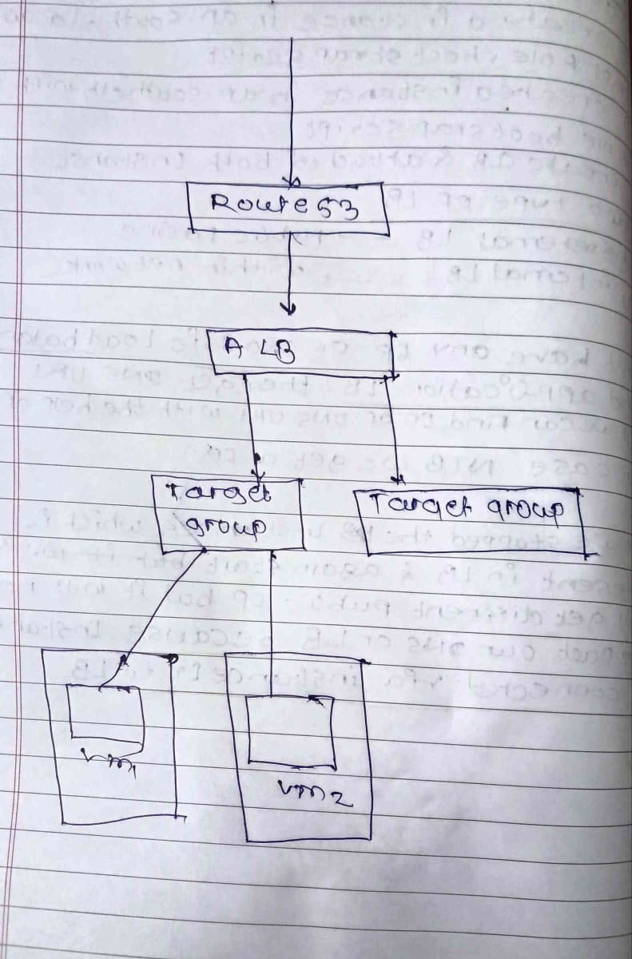
Create a 2 instance in different subnet with custom security group, custom IAM role and with bootstrapping script
Bootstrap script
#!/bin/bash
yum install -y httpd
aws s3 cp s3://demoelb12345/index.html /var/www/html/
service httpd start
chkconfig httpd on
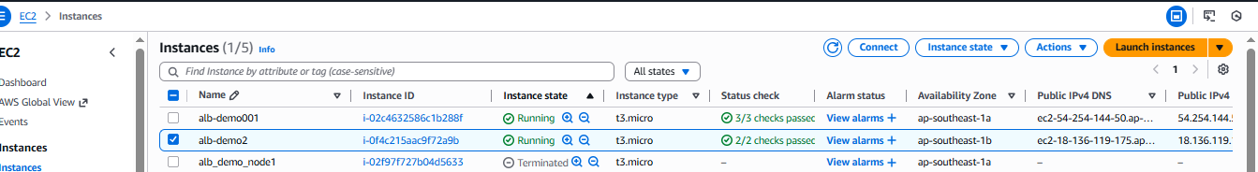

2) Create the Application load balancer, while creating load balancer create the target group for the attached to the ALB

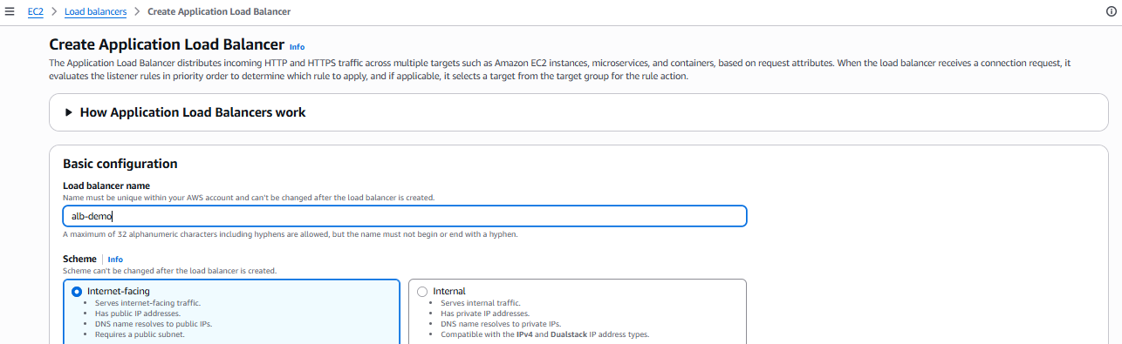
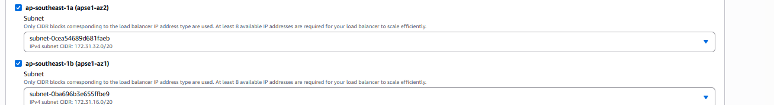
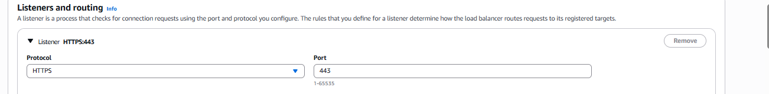
Creating the target group
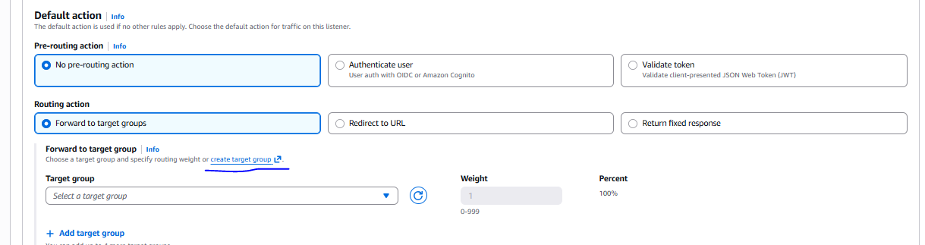
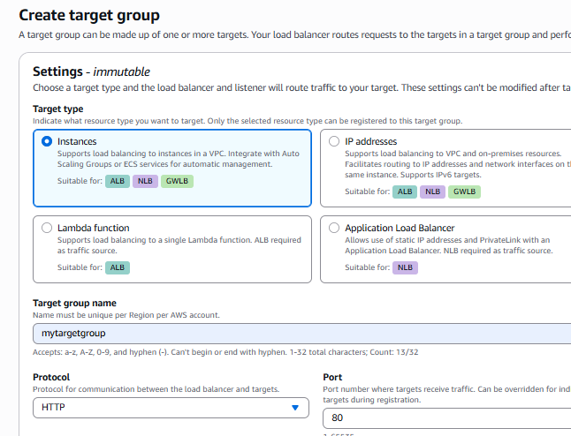
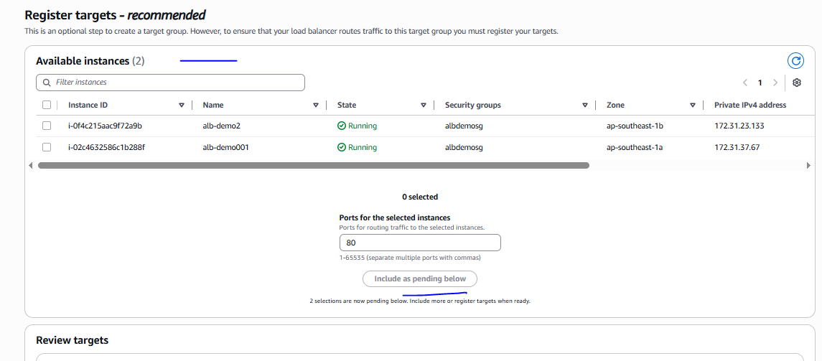
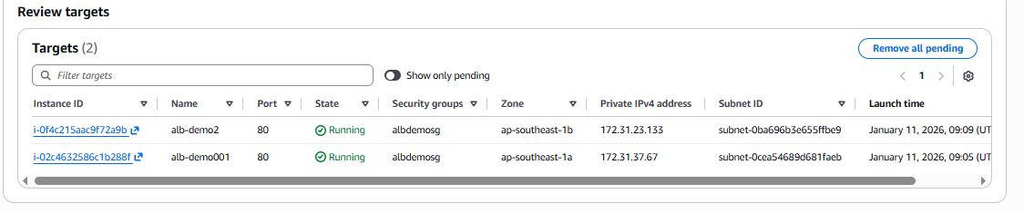
Once target group has created need to attached in the load balancer and create load balancer with
HTTPS listener.
Once load balancer created we can see the healty status is good in a target group
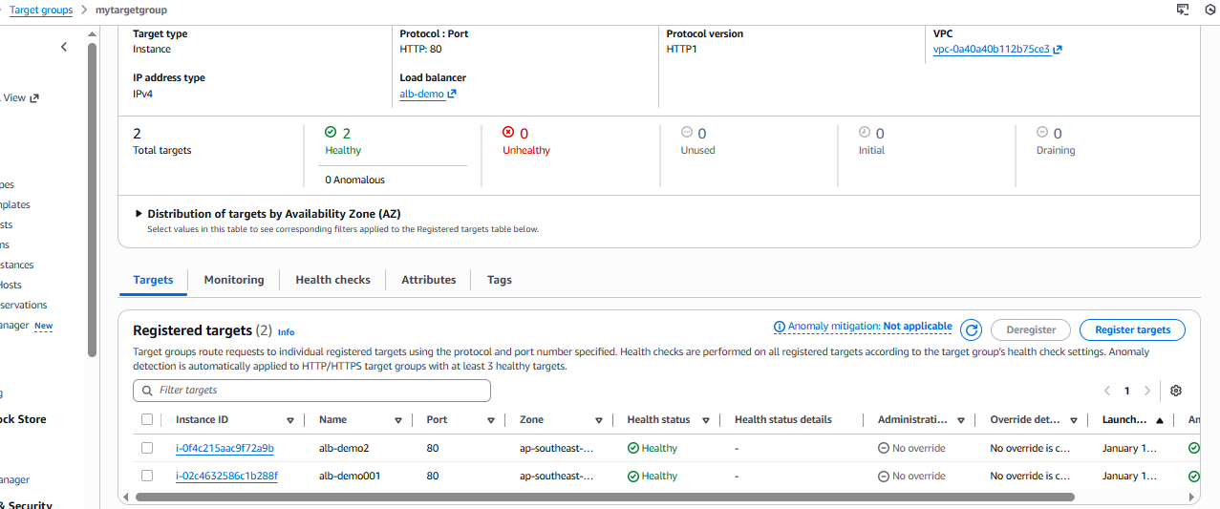

Listener HTTP
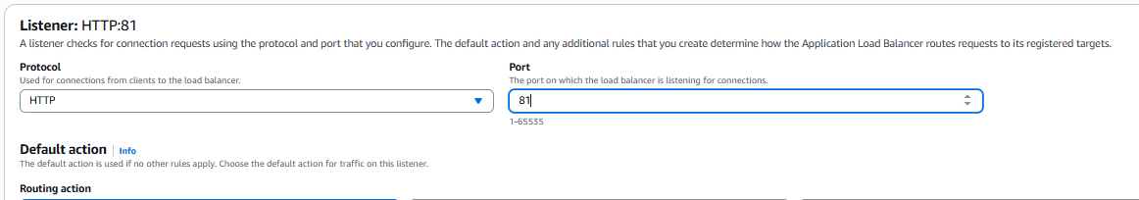

Alb-demo load balancer has been created
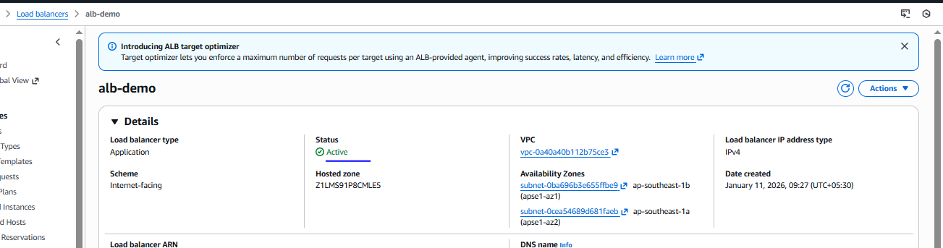

Load balancer working fine without HTTPS
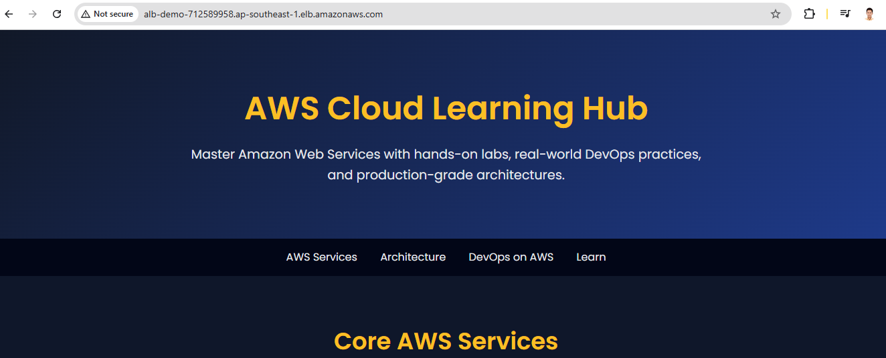

Need to create A record to create the HTTPS and attached the DNS of ALB
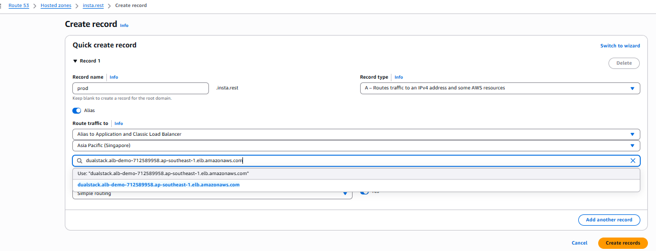
Once we create A record not able to accessible the page
So for this issue need to add the HTTPS listener in the load balancer
